Title: WEEK 2
NETWORK TRAFFIC ANALYSIS, NMAP AND WINDOWS LOGGING



NAME: AAYAT ANSARI
INTERN ID: DG/15/OCT/CYBER/066
DATE:30th Oct 2026
PROGRAM: CSE
SPECIALIZATION: CYBERSECURITY

1.Executive Summary
This report covers Week 2 learning in network traffic analysis, Nmap reconnaissance, and Windows logging. It summarises TCP behaviour, protocol analysis, Wireshark filters, Nmap scan types, Windows components, Security Event IDs, logon types, and baselining for SOC work.
Screenshots shared confirm five TryHackMe rooms completed at 100%: Nmap Live Host Discovery, Nmap Basic Port Scans, Windows Basics, Windows Fundamentals 1, and Windows Fundamentals 2. Separate practical results are not claimed unless supported by actual evidence.

2. Objectives
- Understand TCP connection setup, teardown, and flags.
- Distinguish normal and potentially suspicious DNS, HTTP/HTTPS, ARP, ICMP, and SMB behaviour.
- Use Wireshark filters to isolate relevant packets.
- Understand Nmap host discovery, TCP/UDP scans, service detection, and OS detection.
- Review Windows processes, services, Registry, accounts, UAC, and Event Viewer.
- Interpret key Windows Security Event IDs and logon types.
- Explain baselining and its value to SOC analysts.

3.TCP Fundamentals
TCP is connection-oriented. A typical connection begins with SYN → SYN-ACK → ACK. An orderly close commonly uses FIN/ACK exchanges. RST resets or rejects a connection.

Flag | Meaning | Typical evidence
SYN | Requests connection establishment. | Initial TCP connection attempt.
ACK | Acknowledges received segments. | Handshake completion/data acknowledgement.
FIN | Sender has finished sending data. | Orderly connection teardown.
RST | Resets or rejects a connection. | Closed port or aborted connection, depending on context.
PSH | Requests prompt delivery to the application. | May accompany application data.
URG | Urgent pointer field is significant. | Uncommon in most ordinary modern traffic.

4.Protocal Behavior :Normal vs Potentially Suspicious
Protocol | Normal behaviour | Potentially suspicious behaviour to investigate
DNS | Expected domain queries and responses. | Repeated unusual queries, high volume, unexpected DNS server, possible tunnelling patterns.
HTTP | Expected web requests and server responses. | Unexpected downloads, suspicious destinations, unusual methods, clear-text credentials.
HTTPS/TLS | TLS handshake and encrypted traffic to expected services. | Unusual destinations, certificate anomalies, repeated failed handshakes. Encryption alone is not suspicious.
ARP | Local IP-to-MAC resolution. | Unexpected ARP replies, duplicate mappings, possible spoofing.
ICMP | Ping and legitimate network errors. | High-volume probes, sweeps, unexpected tunnelling patterns.
SMB | Authorised file/printer sharing. | Unexpected SMB connections, lateral movement patterns, repeated authentication failures.

5.Wireshark Display Filter Cheat Sheat –20 Entries
Display filter | Meaning / when to use
ip | Display IPv4 packets.
ipv6 | Display IPv6 packets.
tcp | Display TCP packets.
udp | Display UDP packets.
icmp | Inspect ICMP echo and error traffic.
arp | Inspect ARP requests and replies.
dns | Inspect DNS queries and responses.
http | Inspect packets dissected as HTTP.
tls | Inspect TLS handshakes and encrypted-session metadata.
tcp.port == 80 | Filter TCP traffic involving port 80.
tcp.port == 443 | Filter TCP traffic involving port 443.
ip.addr == 192.168.1.10 | Show IPv4 traffic to or from this example host.
ip.src == 192.168.1.10 | Show packets sourced by this example host.
ip.dst == 192.168.1.10 | Show packets destined for this example host.
tcp.flags.syn == 1 && tcp.flags.ack == 0 | Find initial TCP SYN probes.
tcp.flags.reset == 1 | Find TCP packets with RST set.
dns.flags.response == 0 | Show DNS queries.
http.request.method == "GET" | Show HTTP GET requests.
tcp.analysis.retransmission | Show packets identified as TCP retransmissions.
tcp.stream eq 0 | Isolate TCP stream 0; change the number as needed.

These are display filters, applied after packets are captured or loaded. Capture filters use different syntax; examples include `host 192.168.1.10`, `icmp`, `port 53`, and `tcp port 443`.

6.Nmap Host Discovery and Port Scanning

Nmap (Network Mapper) discovers hosts, identifies port states, and investigates services on systems the operator is authorised to assess.
Option | Purpose | Notes
-sn | Host discovery without a standard port scan. | Discovery behaviour depends on network and privilege.
-sS | TCP SYN scan. | SYN-ACK commonly indicates open; RST commonly indicates closed.
-sT | TCP connect scan. | Uses the OS connect call and completes connections.
-sU | UDP scan. | UDP response may indicate open; no response may mean open|filtered.
-sV | Service/version detection. | Results depend on probe responses.
-O | OS detection attempt. | Accuracy depends on available responses.
-A | Enables several advanced detection features. | More intrusive/noisy; use only with permission.
Example commands for an authorised lab target (replace placeholders with the assigned target):
nmap -sn <target-or-subnet>
nmap -sS <target-IP>
nmap -sT <target-IP>
nmap -sU <target-IP>
nmap -sV <target-IP>
nmap -O <target-IP>
nmap -A <target-IP>
nmap -sS -oN scan.txt -oX scan.xml <target-IP>
Record target scope, date/time, command, and actual result. SYN scans may show SYN probes, SYN-ACK replies from open ports, and RST replies from closed ports. Exact responses depend on target and firewall.

7. Windows Fundamentals and logs
Component/log | Purpose | Security relevance
Processes | Running applications and system tasks. | Investigate unfamiliar processes, command lines, and parent-child relationships.
Services | Background components, often auto-starting. | Unexpected services may indicate misconfiguration or persistence.
Registry | Hierarchical store for Windows/application settings. | Unexpected startup/configuration changes may warrant investigation.
Users/groups | Accounts and assigned permissions. | Unexpected accounts or privileged group membership increase risk.
UAC | Prompts for approval/credentials for elevated actions. | Unexpected elevation requests may merit review.
Application log | Application events. | Troubleshoot application failures.
Security log | Audited security events, subject to policy. | Review logons, account changes, process creation, privilege use, and audit clearing.
System log | OS and service events. | Review service failures and system-level changes.

Event availability depends on audit policy, Windows version, log retention, and where the event is generated. Events 4768 and 4769 are generally reviewed on domain controllers.

8. Windows Security Event ID Cheat Sheet — 15 Entries
ID | What it means | When to use it
4624 | Successful logon. | Review unexpected access, source, time, and logon type.
4625 | Failed logon. | Investigate repeated failures or password guessing.
4634 | Account logged off. | Correlate session endings with logon activity.
4648 | Logon attempted using explicit credentials. | Investigate unusual alternate credential use.
4672 | Special privileges assigned to a new logon. | Review powerful privileges in context.
4688 | New process created. | Investigate suspicious executables/command lines; command-line logging requires configuration.
4697 | Service installed (if audited). | Investigate unexpected service installation.
4720 | User account created. | Review unexpected account creation.
4722 | User account enabled. | Investigate reactivation of disabled accounts.
4724 | Attempt to reset an account password. | Review unexpected resets, especially privileged accounts.
4732 | Member added to a security-enabled local group. | Investigate unexpected Administrators-group additions.
4768 | Kerberos TGT requested. | Review unusual domain authentication on domain controllers.
4769 | Kerberos service ticket requested. | Investigate unusual ticket patterns, including possible Kerberoasting.
4776 | NTLM credentials validated. | Review unexpected NTLM use or repeated failures.
1102 | Security audit log cleared. | Investigate possible log tampering and correlate other evidence.

Interpret logon type with the account, source, timestamp, target system, and business context. Normal behaviour varies by organisation.

10. Baseline and SOC Importance
A baseline is a documented description of normal activity for a system, user, application, or network over a representative period. It can include expected hosts, ports, protocols, DNS destinations, login times, service accounts, process activity, and normal event volumes.
Detect deviations such as unusual ports, destinations, login times, or process launches.
Reduce false positives by documenting approved maintenance jobs and scanners.
Prioritise alerts that differ significantly from expected activity.
Support incident response by showing what changed and when.
Improve reporting through clear, evidence-based comparisons.
A baseline must be updated as systems and business needs change. A deviation is a lead for investigation, not proof of an attack.

11. Practical Exercises and Evidence Checklist
A. Network traffic capture
Filtering TCP Traffic Using Wireshark
The TCP display filter was applied in Wireshark to analyze TCP connections and HTTP communication between the Kali Linux and Ubuntu systems.

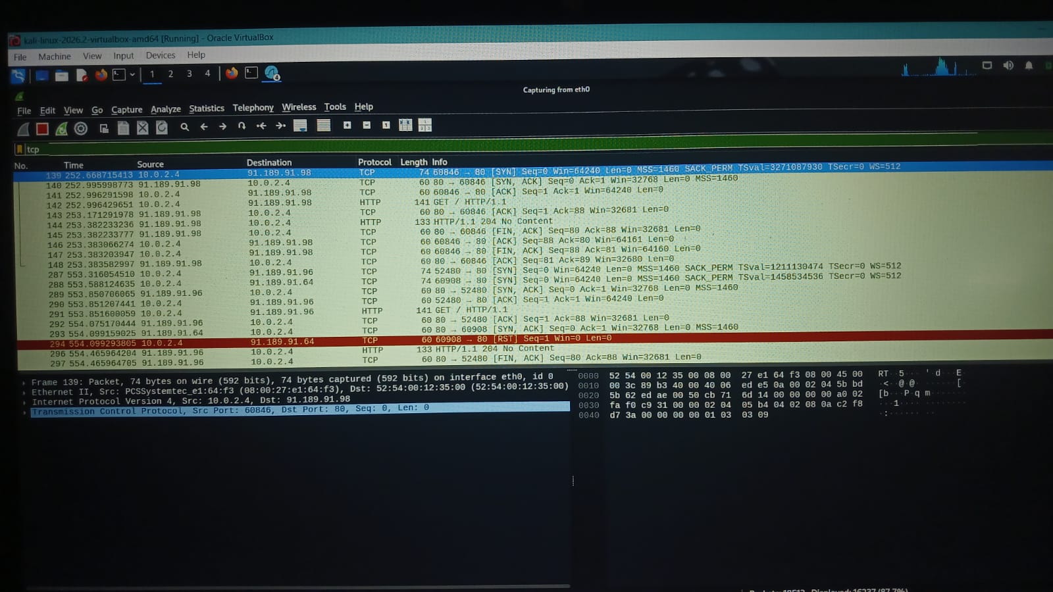

HTTP Protocol Analysis
- The HTTP filter was applied in Wireshark to identify HTTP request and response packets between the source and destination IP addresses.
- The capture shows an HTTP GET request and an HTTP 200 OK response, indicating that the server successfully responded to the request.
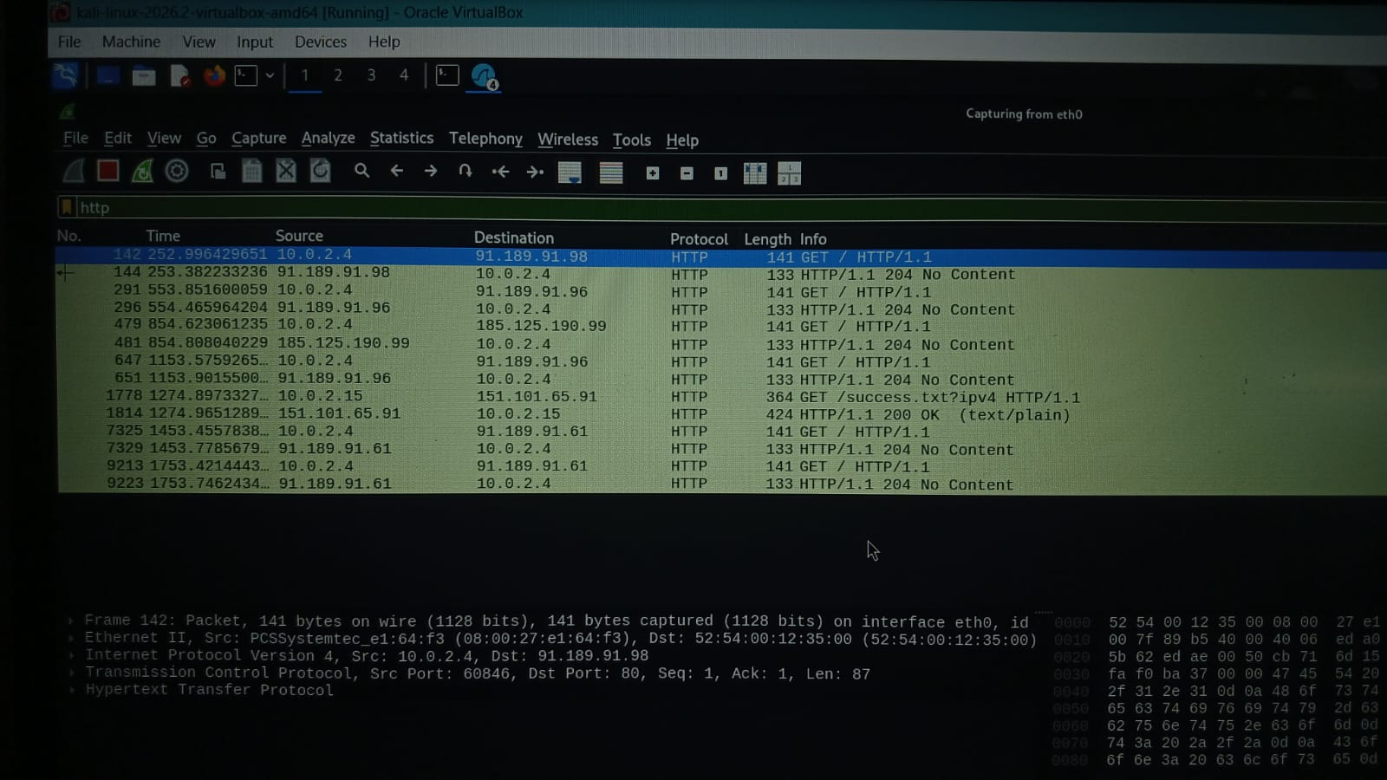

ICMP Protocol Analysis
- The ICMP filter was applied to capture and analyze ping request and reply packets between two IP addresses.
- The captured packets show successful ICMP echo requests and replies, confirming network connectivity between the devices.
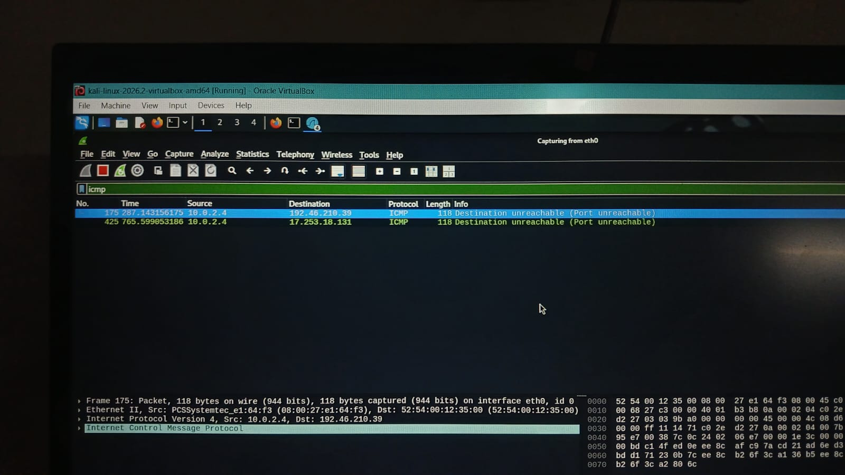
DNS Protocol Analysis
- The DNS filter was applied in Wireshark to identify DNS query and response packets exchanged between the client and DNS server.
- The captured packets show DNS queries and responses, demonstrating the process of resolving domain names into IP addresses.
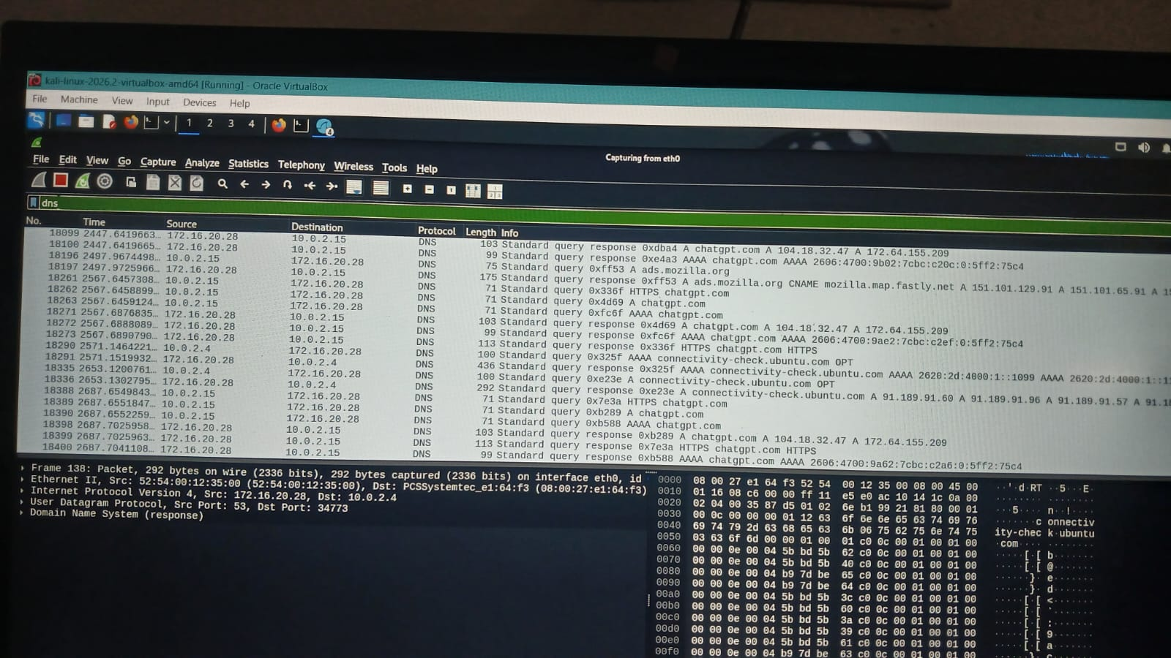

1. The Wireshark capture shows TCP SYN packets being sent to the target IP address to scan multiple ports and identify which ports are open.
2. The source IP 10.0.2.4 sends connection requests to the destination IP 91.189.91.98 on multiple ports such as 443, 80.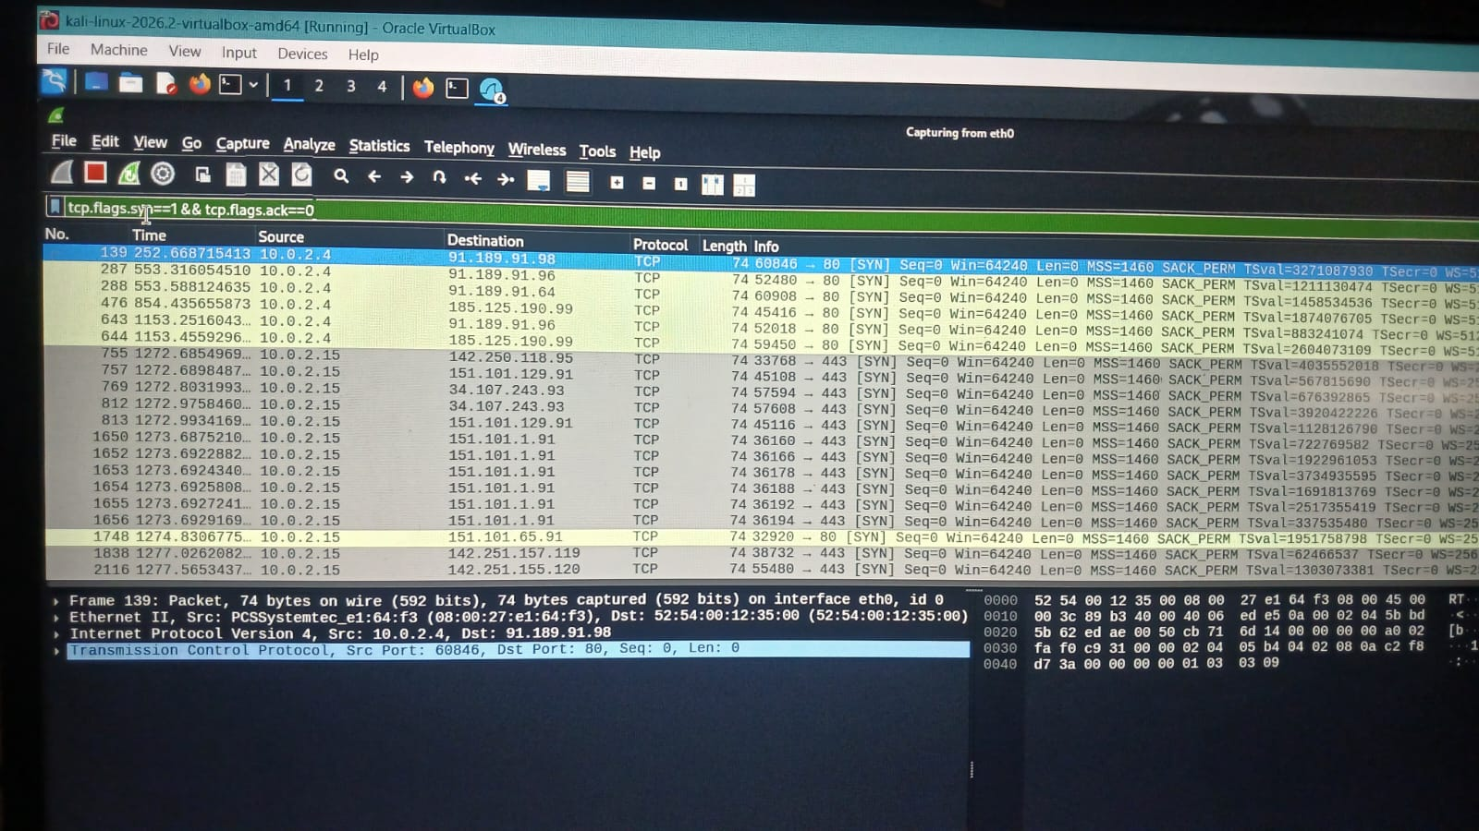

B. Nmap scans

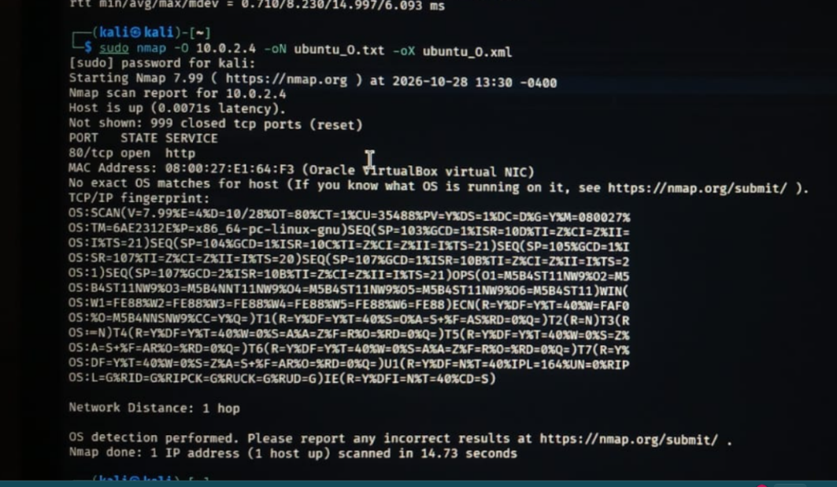
1. The Nmap scan confirms that the target host 10.0.2.4 is active, with TCP port 80 (HTTP) open, indicating that a web service is accessible.
2. The scan identified 999 closed TCP ports and captured TCP/IP fingerprint data, providing useful information for operating system assessment and network security analysis.
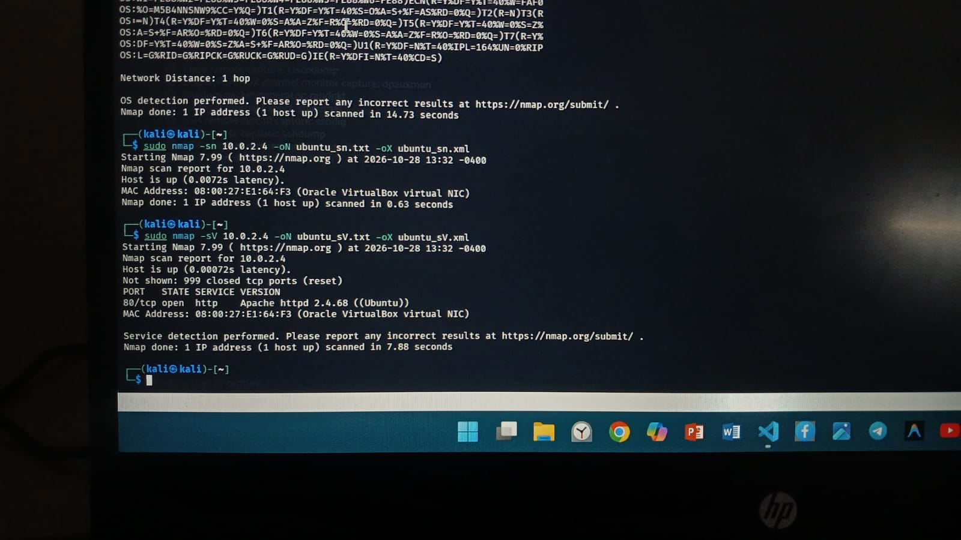

1. The Nmap service version scan identified Apache HTTP Server 2.4.66 running on Ubuntu at the target IP address 10.0.2.4, with TCP port 80 open.
2. The host discovery and service detection scans confirmed that the target system is active and its web service is accessible, providing valuable information for network reconnaissance and security assessment.

C. Windows Event Viewer
Open Event Viewer and inspect Windows Logs → Security, Application, and System.
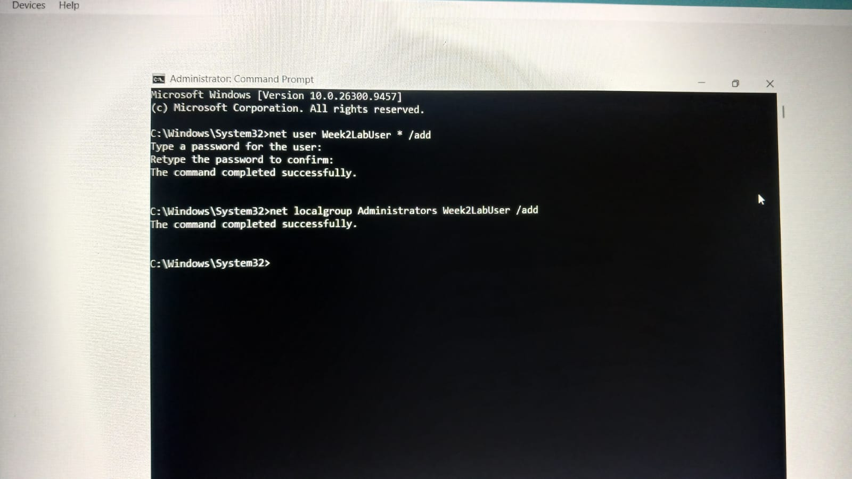
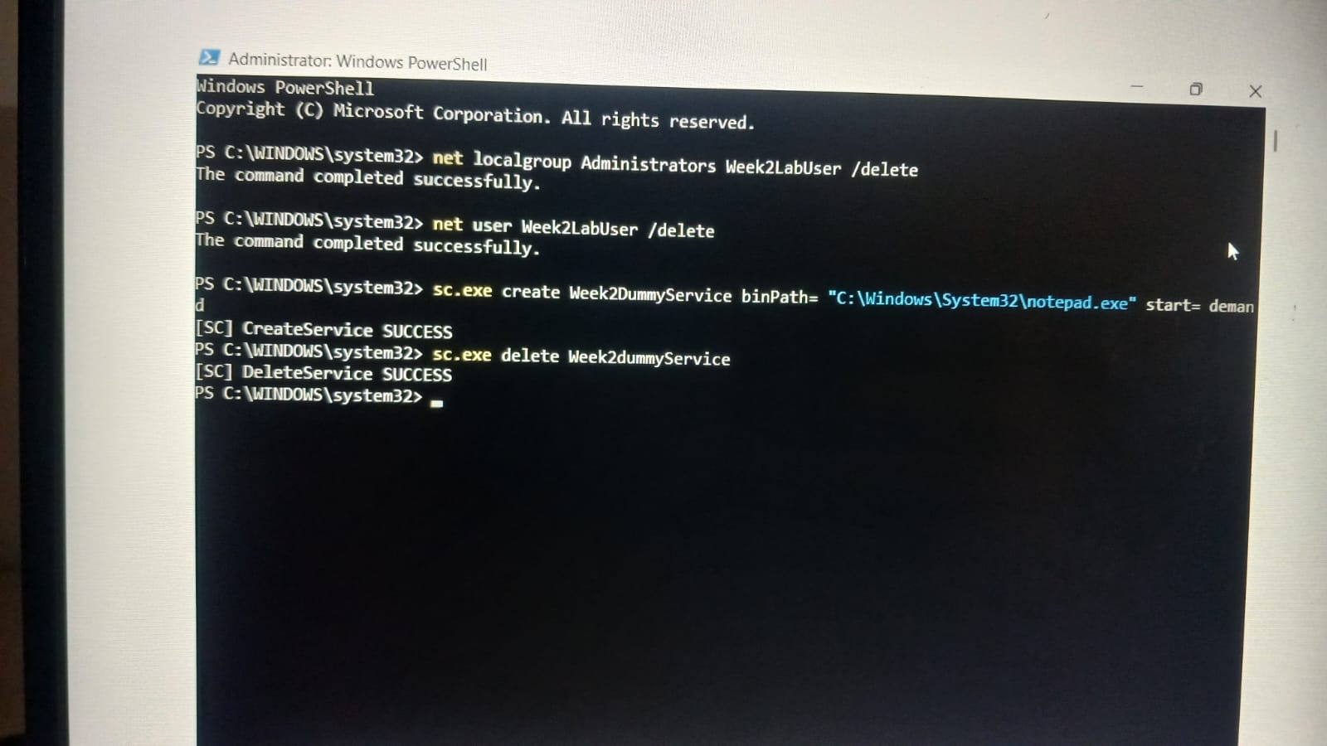
- Filter relevant IDs such as 4624, 4625, 4720, 4732, and 1102 if present.
- Use only a disposable, authorised lab VM and test accounts. Do not clear logs on a production or personal system.
- Record event ID, timestamp, account, logon type, source, and relevant details; redact sensitive information.

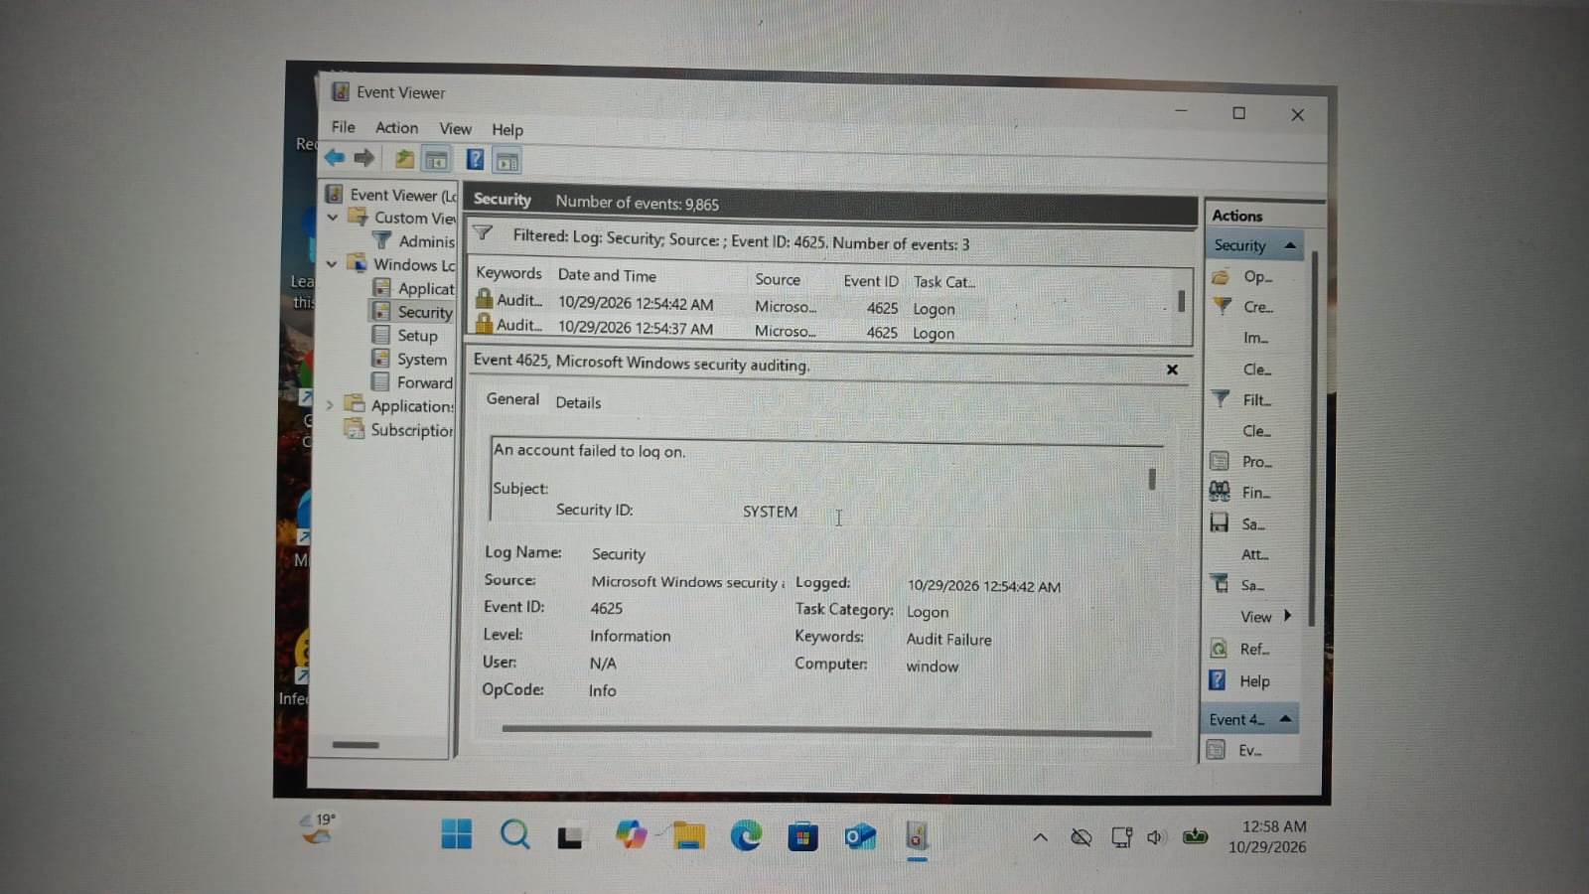
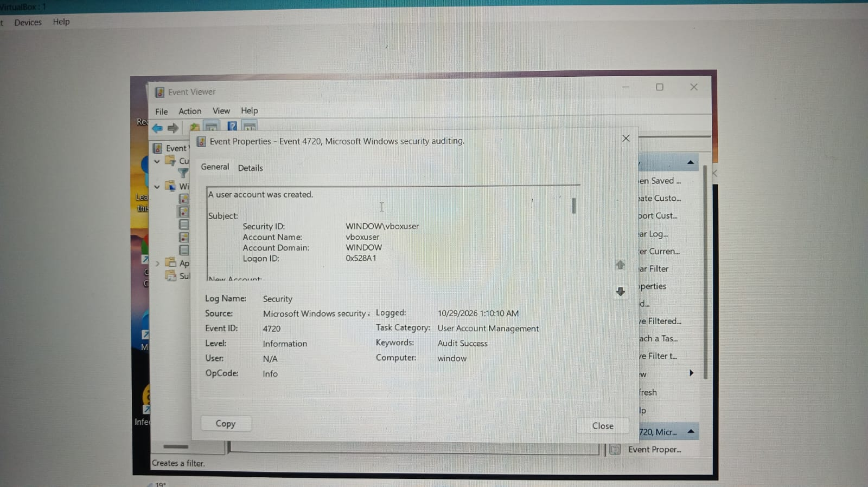
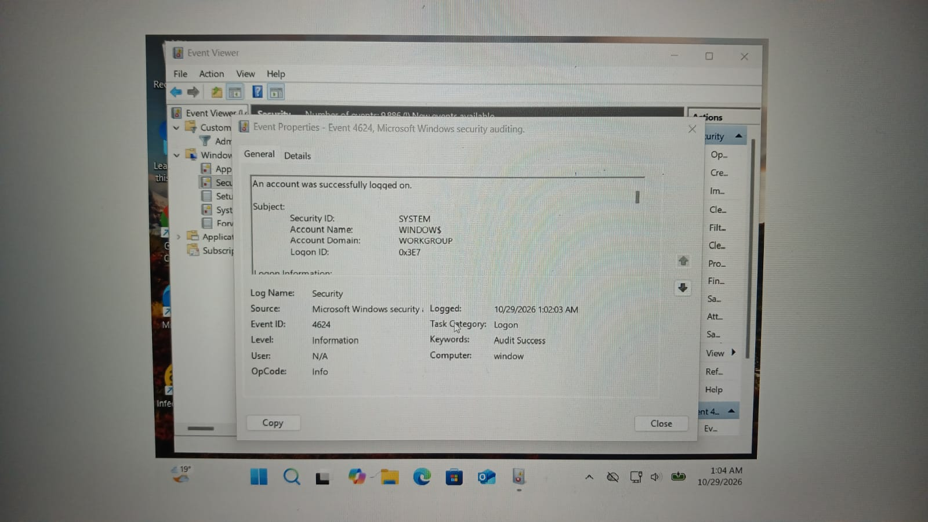
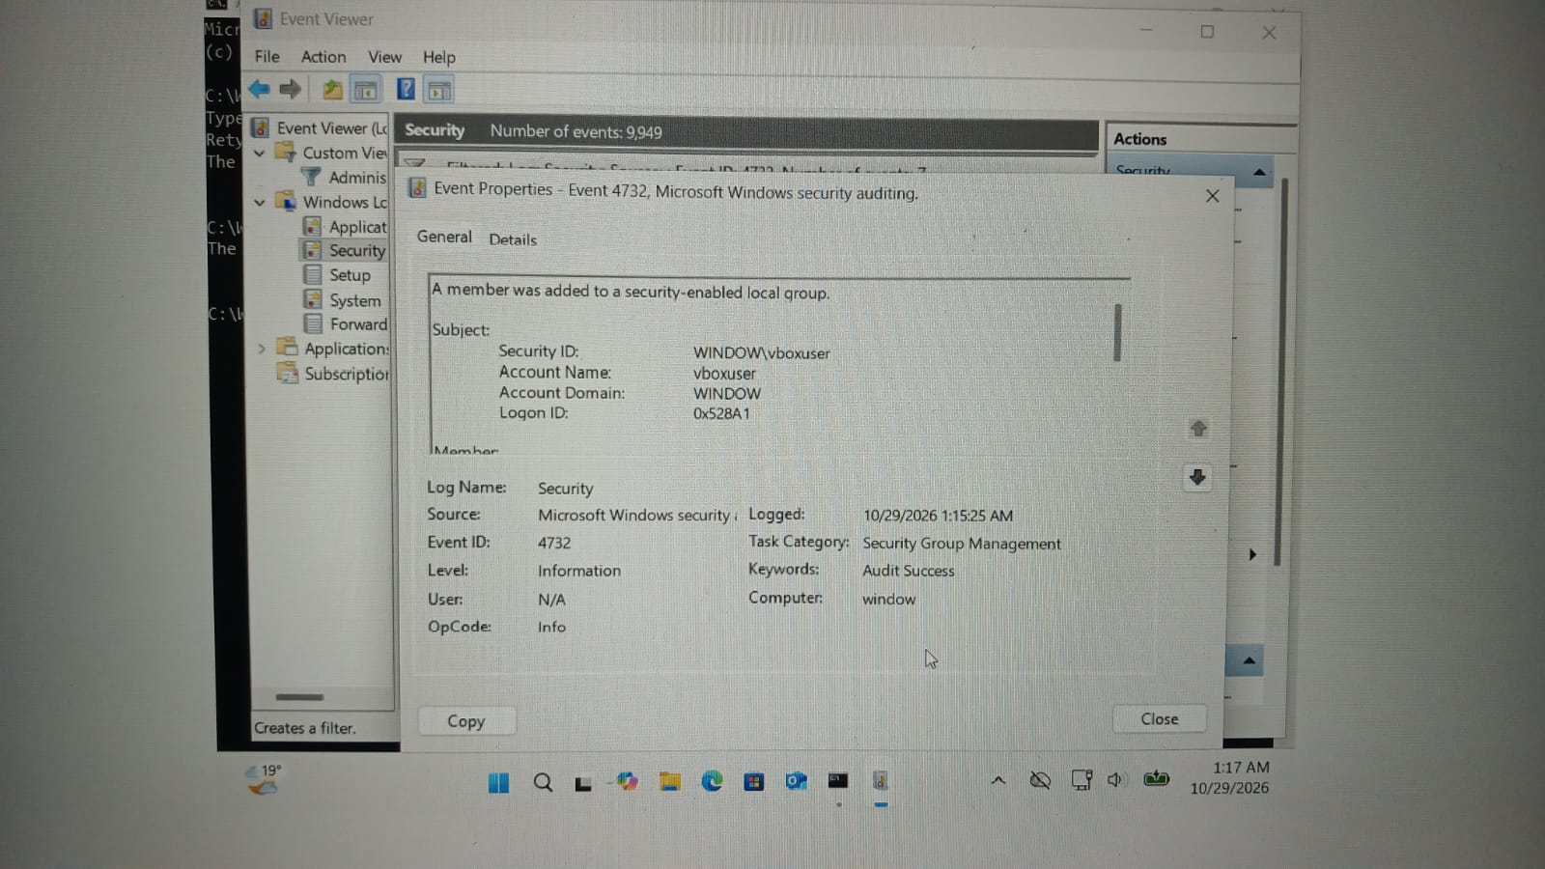
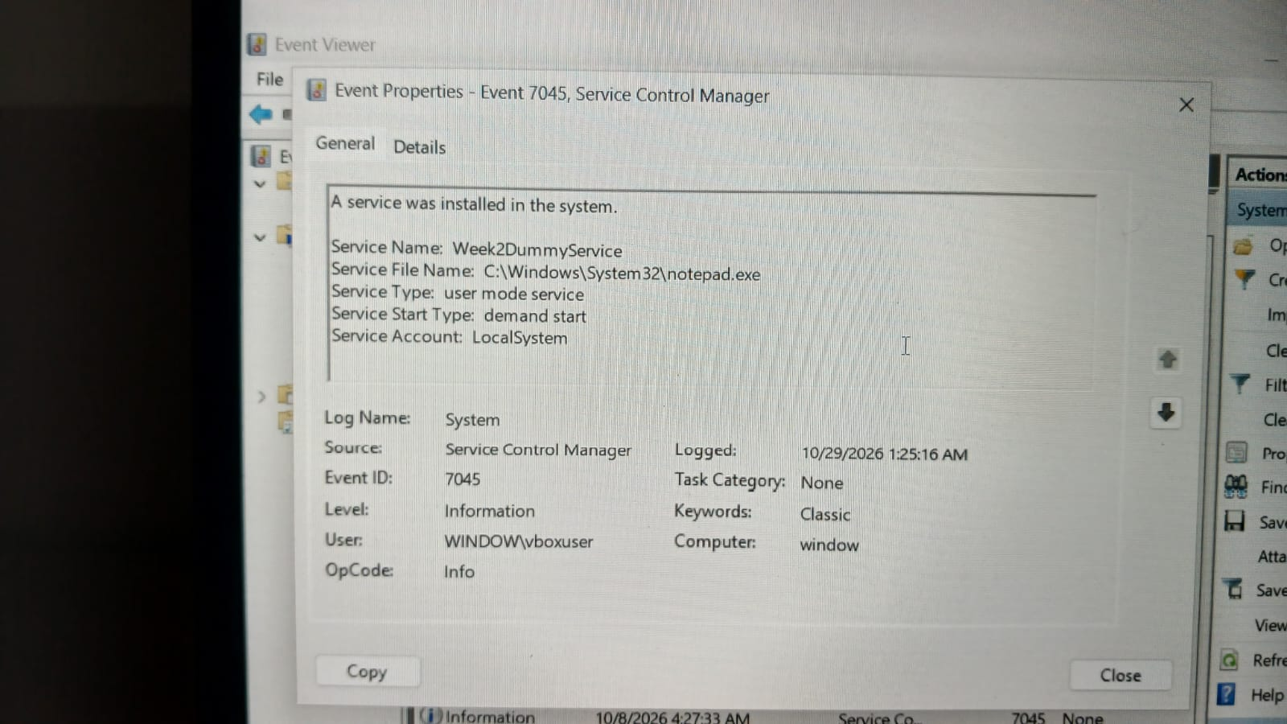
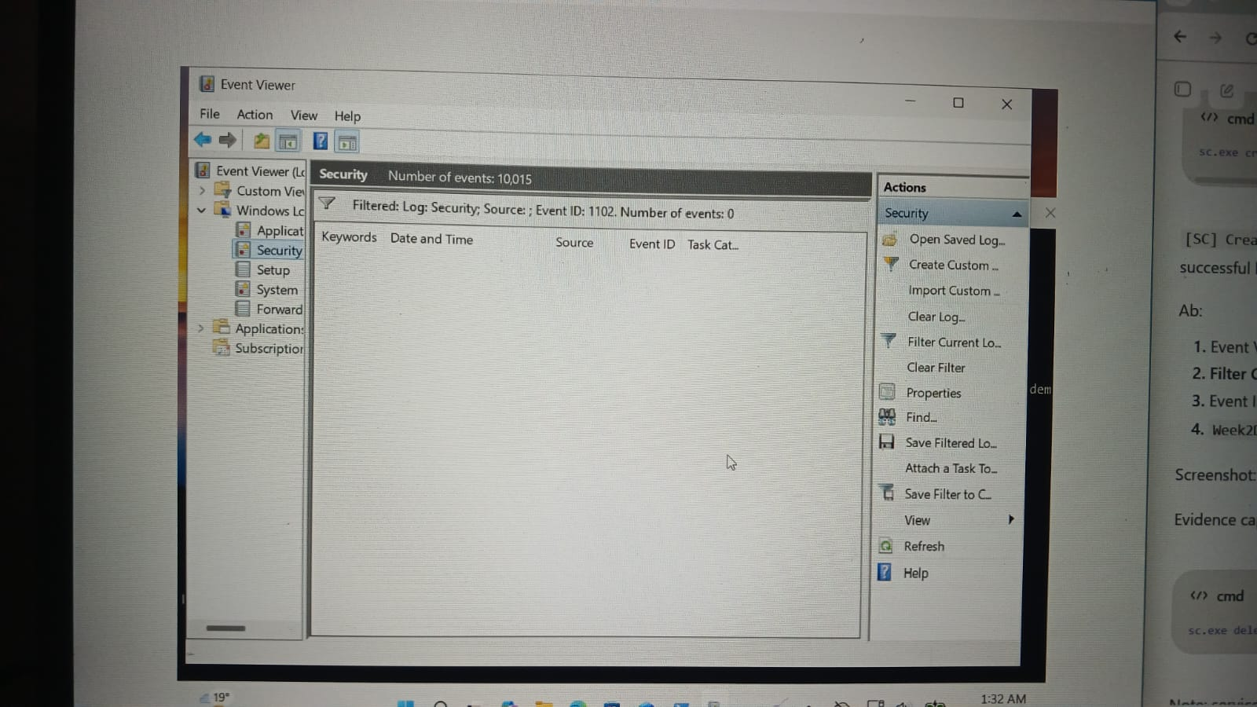

12. TryHackMe Learning Evidence
The objective of this room was to understand how Nmap discovers live hosts on a network using different discovery techniques, including ARP, ICMP, and TCP/UDP probes.

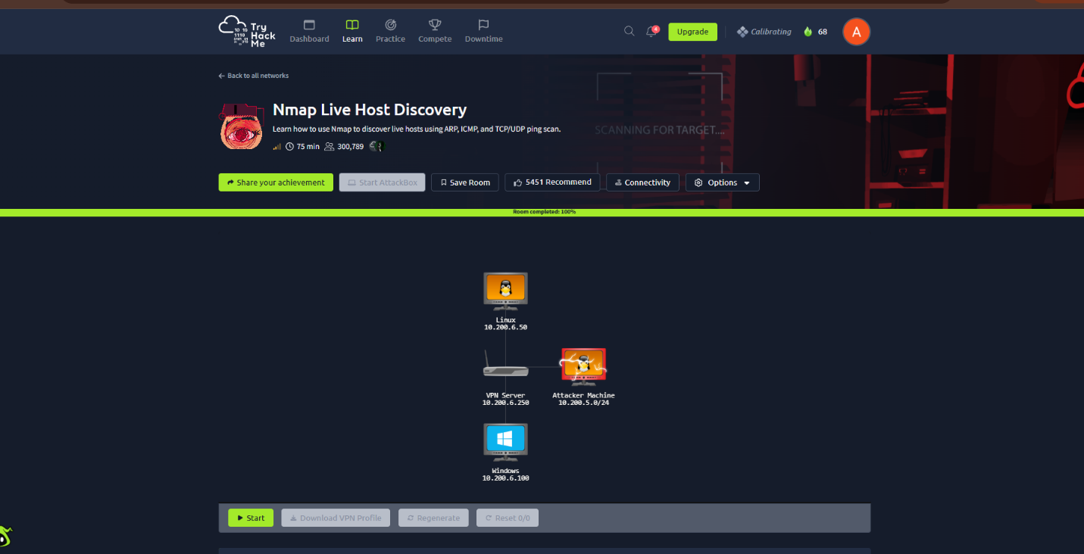
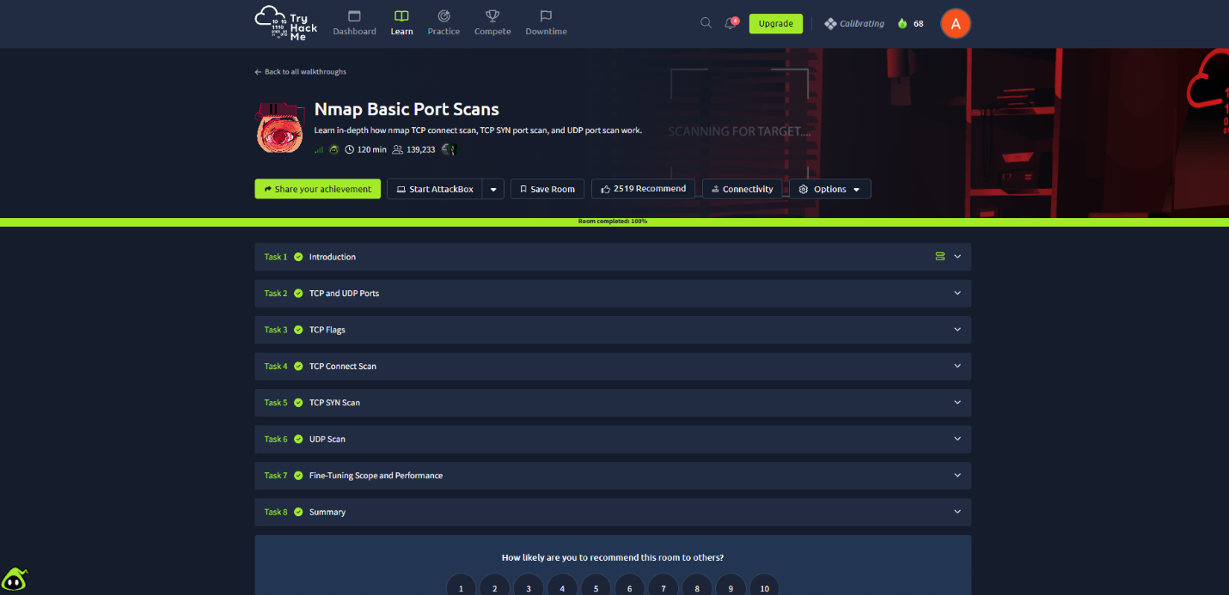
The objective of this room was to understand how Nmap performs TCP and UDP port scans, how TCP flags work, and how scan responses help identify open, closed, and filtered ports
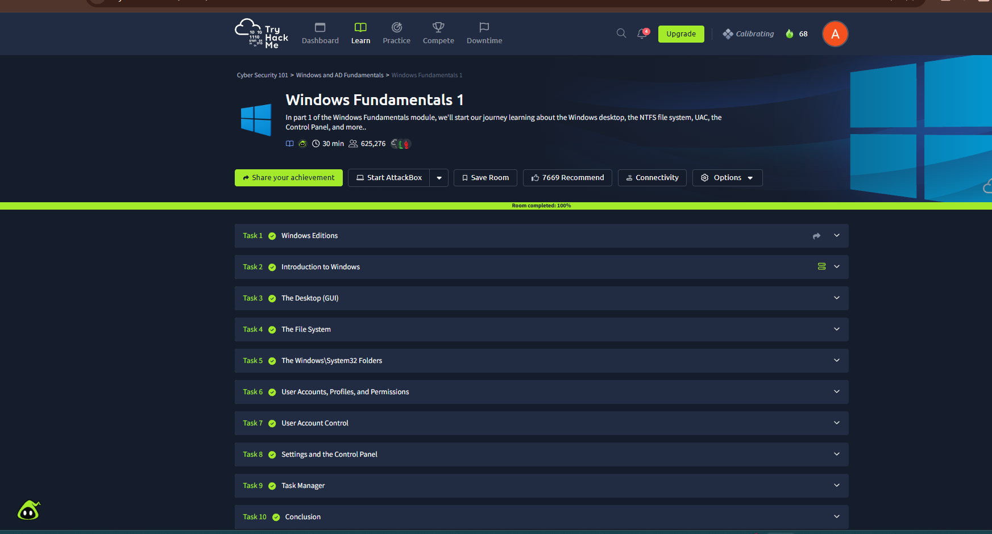

The objective of this room was to learn about Windows editions, the Windows desktop environment, the NTFS file system, User Account Control (UAC), and essential Windows configuration tools.

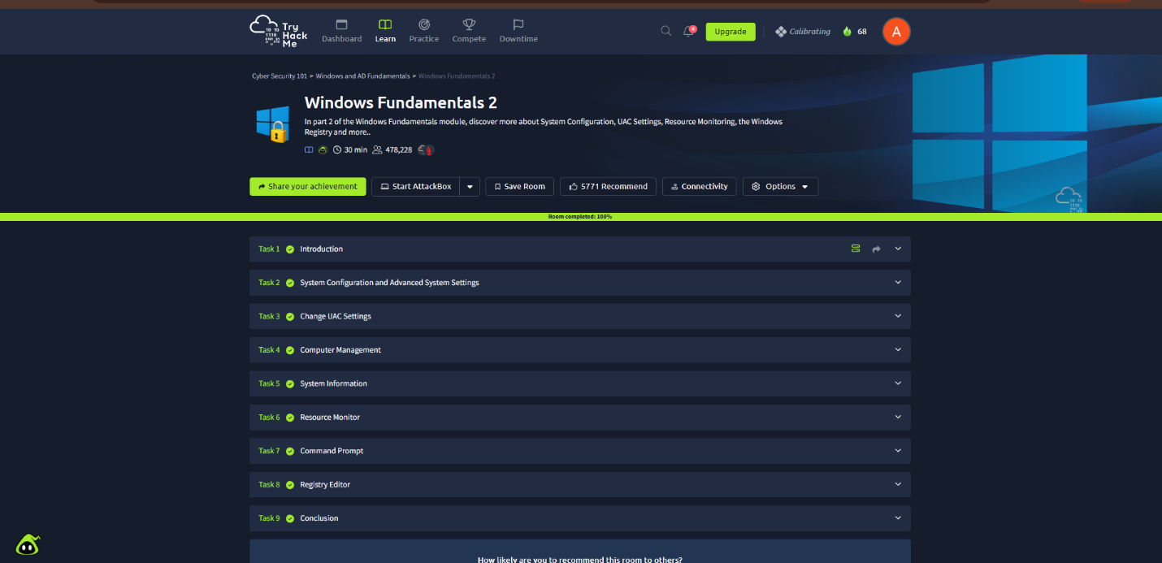
The objective of this room was to understand Windows system configuration, User Account Control (UAC), Computer Management, resource monitoring, and the Windows Registry.

13.Wireshark Sample Capture Analysis: HTTP with JPEG
Tool: Wireshark
Capture File: http-withjpeg.cap
Category: Network Traffic Analysis
Objective: To examine HTTP traffic containing JPEG image data and identify potentially suspicious file transfers.
1. Introduction
Wireshark is a network protocol analyzer used to capture and inspect network packets. HTTP traffic analysis can help identify web requests, server responses, and file downloads.
This analysis focuses on examining HTTP communication and determining whether JPEG image data is transferred between a client and a web server.
2. Protocols to Identify
- Ethernet: Provides communication at the data-link layer.
- IP: Identifies source and destination IP addresses.
- TCP: Provides reliable transport between the client and server.
- HTTP: Carries web requests and responses.
- JPEG: An image format that may be transferred as part of an HTTP response.
3. Analysis Procedure
- Download http-withjpeg.cap from the official Wireshark Sample Captures website.
- Open the capture in Wireshark.
- Apply the display filter http to isolate HTTP packets.
- Inspect HTTP GET requests and corresponding server responses.
- Check response headers such as Content-Type and Content-Length, when present.
- Follow the relevant TCP stream to examine the HTTP conversation.
- If the capture contains image data, investigate whether Wireshark can export the transferred object through File → Export Objects → HTTP.

4. Wireshark Filters
Filter | Purpose
http | Displays packets Wireshark identifies as HTTP.
http.request | Displays HTTP requests.
http.request.method == "GET" | Displays HTTP GET requests.
tcp | Displays TCP traffic.
ip.addr == <IP-address> | Filters traffic involving a specified IP address.

14.Nmap Network Scanning

Internship Assignment: Week 2 – Network Traffic Analysis, Nmap and Windows Logging
Topic: Nmap
Platform: TryHackMe
Objective: To understand network scanning, host discovery, port scanning, and service enumeration using Nmap.
1. Introduction
Nmap (Network Mapper) is an open-source tool used to discover hosts and services on a computer network. It helps security professionals identify active devices, open ports, running services, and potential security risks.
During this practical exercise, I learned how Nmap scans networks and how different scan options help identify hosts, ports, and services.
2. Tasks Performed
Task 1: Host Discovery
Host discovery is used to identify which devices are active on a network.
Command used:
nmap -sn <ip>
Observation: The scan attempts to discover active hosts on the specified network without performing a normal port scan.
Learning: Host discovery helps identify live systems before performing further security assessments.
Task 2: TCP Port Scanning
Port scanning helps determine which TCP ports are open, closed, or filtered.
Command used:
nmap -sS <target-IP>
Observation: The TCP SYN scan sends SYN packets to target ports and analyses the responses to determine their state.
Learning: An open port commonly responds with SYN-ACK, while a closed port commonly responds with RST. Filtered ports may not respond or may return an ICMP error.
Task 3: TCP Connect Scan
Command used:
nmap -sT <target-IP>
Observation: This scan uses the operating system's connect() function to establish a full TCP connection to open ports.
Learning: A TCP connect scan is useful when SYN scanning is unavailable, although completed connections may be more visible to the target service.
Task 4: Service Version Detection
Command used:
nmap -sV <target-IP>
Observation: Nmap probes discovered ports to identify the services and, where possible, their versions.
Learning: Service version detection helps administrators identify outdated or potentially vulnerable software that requires further verification.
Task 5: Operating System Detection
Command used:
nmap -O <target-IP>
Observation: Nmap analyses network responses to estimate the target operating system.
Learning: Operating system detection can help build an inventory of network devices. Its accuracy depends on the target, network conditions, and available responses.
Task 6: Aggressive Scan
Command used:
nmap -A <target-IP>
Observation: This option enables multiple detection features, including operating system detection, service/version detection, default scripts, and traceroute.
Learning: Aggressive scanning provides more information about a target but generates additional probes and may be more noticeable.
3. Key Findings
- Nmap can discover active hosts and identify accessible network ports.
- Different scan types provide different levels of information.
- Service and operating system detection help identify assets and assess potential exposure.
- Scan results must be interpreted carefully because firewalls, filtering, and network conditions can affect accuracy.
- Nmap should only be used on systems and networks for which permission has been granted.
4. Security Importance
Nmap is useful for network inventory, security assessments, and identifying exposed services. Security analysts can use scan results to investigate unexpected open ports, verify firewall rules, and identify services that need patching or configuration changes.
5. Conclusion
Through the TryHackMe Nmap practical exercises, I developed an understanding of host discovery, TCP scanning, service version detection, operating system detection, and aggressive scanning. This practical work improved my understanding of network reconnaissance and the importance of monitoring exposed services as part of cybersecurity operations.
Evidence to attach: TryHackMe task-completion screenshots, terminal output, and scan results from the authorized lab environment.
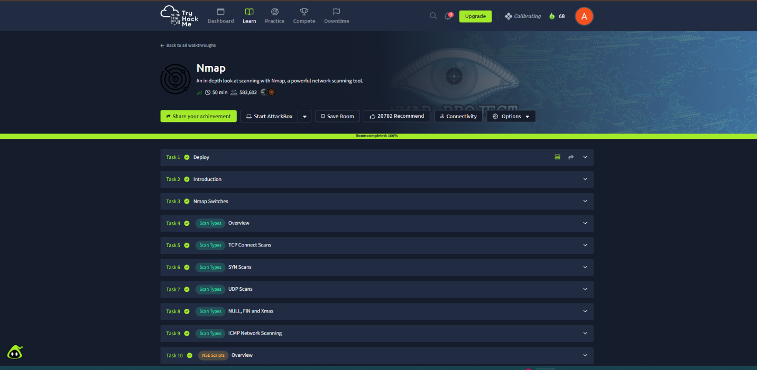

15. Conclusion
These topics establish a practical foundation for network and endpoint security monitoring. TCP and protocol analysis explain communication patterns; Nmap identifies reachable hosts and exposed ports in authorised environments; Windows logs provide evidence about authentication, privilege use, process creation, account changes, and audit activity.

